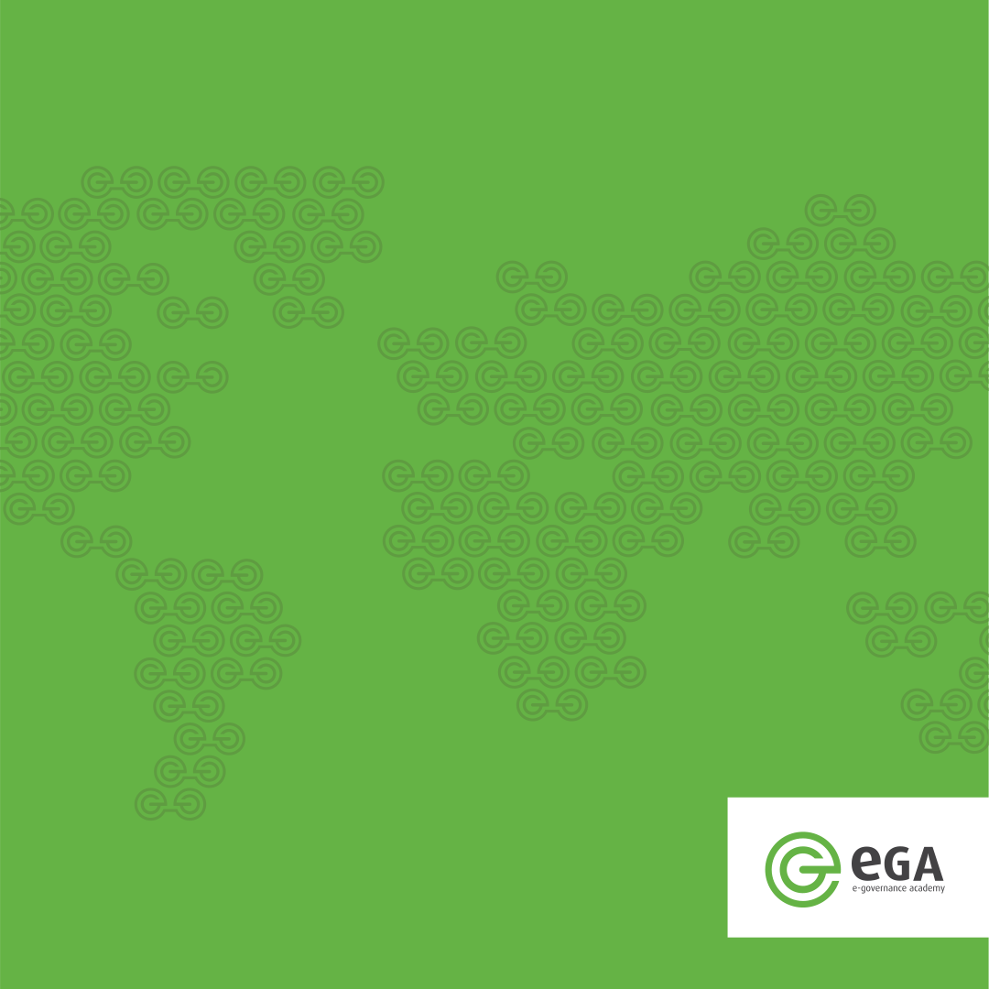

The Catalogue of Interoperability Solutions: CatIS
User guide

Version: 9nd March 2016

Acknowledgments

The catalogue of interoperability solutions (CatIS) is tool for getting clear view of the IT resources in public sector. In catalogue You can register data:
- about institutions: owners, administrators, developers and consumers of registers and information systems;
- about registers and information systems;
- about services;
- about reusable components: semantic assets, guidelines, etc

CatIS is a platform independent solution. It is based on Mongo database. For implementing CatIS in specific country additional set up needed. CatIS is expected to use in two or more languages. It is recommended to use English language interface additionally to the national language.

This paper is oriented to the coordinating staff of information systems in country, to the responsible managers of information systems and interoperability solutions.

For implementing Catis in Your country please contact info@ega.ee.

This paper is written by e-Governance Academy expert Uuno Vallner (Uuno.Vallner@ega.ee ).

Software is developed by Mati Ustav (Mati.Ustav@upmind.ee). Software is based on the MongoDB.

Sandbox: https://upmind.ee/catis/

Content

Content 3
1. Introduction 4
2. Users Rights 5
3. Data Structure 6
4. Data about Institution 7
4.1. Section: institution 7
4.1.1. Field group: General Data 7
4.1.2. Field Group: Contact Persons 8
4.1.3. Field Group: Events and Decisions 8
5. Data about Information Systems 9
5.1. Section: Description 9
5.1.1. Field group: General Data 9
5.1.2. Field Group: Related institutions, Systems and Assets 10
5.1.3. Field Group: Contact Persons 10
5.1.4. Field Group: Tools. Standards. Protocols 10
5.1.5. Field Group: Events and Decisions 11
5.2. Section: Parameters 11
5.2.1. Field Group: SLA, security and other parameters 11
5.3. Section: Data description 12
5.3.1. Field Group: Documents 12
5.3.2. Field group: Data objects and Elements 12
5.4. Section: Documents 13
5.4.1. Field group: Base Documents 13
5.4.2. Field group: Technical Documents 14
6. Data about services 15
6.1. Section: Service 15
6.1.1. Field group: General Data 15
6.1.2. Field group: Service Level Agreements 15
6.1.3. Field group: Namespaces 16
6.1.4. Field group: Service input 16
6.1.5. Field group: Service Output 17
6.1.6. Field Group: Contact Persons 17
6.1.7. Field Group: Consumers 18
7. Data about assets 19
7.1. Section: Asset 19
7.1.1. Field group: General Data 19
7.1.2. Field Group: Contact Persons 19
7.1.3. Field group: Documents 20
7.1.4. Field Group: Events and Decisions 20

1. Introduction

The catalogue of interoperability solutions (CatIS) provides trustworthy assistance and tool for the coordinators, developers, administrators and users of the state’s information system.
The objective of the catalogue is to give a clear view of the IT resources in public sector. Catalogue contains information:
- about institutions: owners, administrators, developers and consumers of registers and information systems;
- about registers and information systems;
- about services;
- about reusable components: semantic assets, guidelines.

e-Government Academy has been helped many countries to improve their national information systems and to implement interoperability solutions. One of the first problems in coordinating public sector information systems is getting information about registers, services, assets, institutions, persons who are responsible for information systems.

CatIS guarantees the transparency of the administration of the state’s information system and helps to plan the state’s information management.
CatIS gives information on the following subjects:
- Which are the information systems and databases that make up the state’s information system;
- Which data are collected and processed and in which information systems;
- Which services are provided and who is using them;
- Who are the responsible and administrators of the information systems and databases, and who are the contact persons;
- On which legal basis are the databases operated and the data processed;
- Which reusable components ensure the interoperability of information systems (XML assets, classifications, dictionaries and ontologies.

CatIS serves as the procedural and administrative environment for the following actions:
- The registration and approval of information systems and databases;
- The registration of services;
- The registration connections with the X-Road;
- The administration of reusable components (XML assets, classifications, dictionaries and ontologies).

CatIS provides trustworthy assistance and is a great tool for the developers, administrators and users of the state’s information system.

2. Users Rights
There is four type of users: administrator of CatIS, administrator of institution, administrator of solutions, public user.

Administrator of CatIS.
The application administrators have access to all parts of the application and edit rights to all objects, therefore this level of access should only be granted to as few people as possible.
Only application administrators can modify forms, designate other users as application admins, edit and delete user accounts.
Also, only application administrators can create new institutions and delete them.

Administrators of CatIS are usually persons coordinating information systems in this country. They can:
- Read, list, search and download all data;
- Change all data;
- Grant to others rights of institution administrator;
- Grant rights to others CatIS administrators;
- Responsible for integrity and availability of CatIS

Administrators of institution.
When a new institution has been created in the catalogue, it is then possible to register new user accounts for that institution's users. Initially, application administrator should register the first institution user and set the institution administrator role. This is done on the "User Accounts" tab of the institution page. This user can later add other user accounts and possibly mark them as institution admins as well.

Users can be added to institution by creating a completely new user or by assigning an existing user as this isntitution's user.

All users created from the institution "User Accounts" page are automatically related to that institution.

Administrators of institution:
- Can read, list, search and download all data;
- Can change institution data;
- Can Grant to others rights of institution administrator;
- Is responsible for institution data.

Administrator of solutions.
Owners of information systems services and assets can be selected from the institution users on the Owners tab on the object's page. Only users assigned as owners can edit object's data.

Public users can read, list, search and download unhidden data. For public users are hidden data about administrators. They cannot change any data.

3. Data Structure

Main objects of CatIS are: Institutions, Systems, Services and Assets. Every institution is owner of some Systems and/or some Assets. Every system may have some services

Institution subbase contains metadata about Institution: name, registry code, URL, etc. In the catalogue are registered only Institution who are owners of some Systems and/or Assets. Subbase includes data about contact persons of every institution and list of important Events and Decisions.

The subbase of Systems provides metadata about government databases: the name of the database, owner, type of registered data, list of services, description of technical architecture, list of legal acts, etc.

The aim of Service Repository is to ensure the interoperability of public sector information systems and the reuse of technical, organizational and semantic resources. The Service repository includes specifications for all web services, and detailed description of government services.

The Repository of Assets includes description of interoperability solutions: any common frameworks, common services, building blocks and generic tools facilitating cooperation between disparate and diverse public organizations.
For describing the main objects of CatIS we use the following hierarchy of elements: key elements, section, field groups, fields. Key elements of main objects are name of object and identifier of object. Field groups may recur. The number of repetitions may be fixed. Sections, field groups and elements can be hidden: available only for logged users. Elements can be empty or required. Elements type are: text, number, date, e-mail, URL, textarea, checkbox, select one, select multiple, file. Field types are described below:
- Text: a brief one-line string (max 256 characters)?
- Number: a natural number?
- Date: a date chosen from calendar
- e-mail: an e-mail address
- URL: Link to the Internet source
- Textarea: longer plain text
- Checkbox: a list of small squares that you click on with your mouse to choose a feature
- Select one: You can choose one of the options
- Select multiple: You can choose many of the options
- File: You can upload any file, maximum size of files in one object is 10MB

CatIS supports a multi languages environment. Original language is English. By choosing others languages you see the same data, but user interface elements and names of sections, field groups and fields are translated to the selected language.

4. Data about Institution

4.1. Section: institution

4.1.1. Field group: General Data
Repeating: 1, hidden: no

Name. Name of institution. Default element. You do not need define this element. It is generated by system. Example: Majandus- ja Kommunikatsiooniministeerium

Identifier. Short name or code of institution. Default element. You do not need define this element. It is generated by system. Example: MKM

Name in English. Example: Ministry of economic affairs and communications

Registry Code. Official code of institution given by government. Not required. Example: 90007000

URL. Link to the institution official website. Not required.

Description. Description of institution: strategical, organizational, financial view.
Example:
The e-Governance Academy (eGA) is a think tank and consultancy organisation founded for the creation and transfer of knowledge and best practice concerning e-governance, e-democracy, national cyber security and the development of open information societies.
eGA trains and advises leaders and stakeholders in using information and communications technology (ICT) to increase government efficiency and to improve democratic processes. Additionally, in cooperation with IT-companies eGA assists in the implementation of e-government technical solutions.

Type. Type of organization. Checkbox options: Central Government; State Institution, Public Body, Local Government, Local Government Body, Private Body, NGO, Other. Example: NGO
Required field.

Role. Role of institution. Checkbox options: Service Provider, Service Consumer, Solution
Developer, Asset Owner, Standard Solution Owner, Other. Required field

Status. Status of institution in CatIS. For joining CatIS institution have to fulfill some requirements and get approval from coordinating body. Institution start the joining process with application. Results of approval are registered in events field group (see 4.2.3). Checkbox options: Application, Member, Terminated. Not required.

X-Road. Status of joining institution with X-Road. For joining X-Road institution have to fulfill some requirements and get approval from coordinating body. Institution start the joining process with application. Results of approval are registered in events field group (see 4.2.3). Checkbox options: Application, Member, Terminated. Not required.

4.1.2. Field Group: Contact Persons
Repeating: unlimited, hidden: yes

Name. Name of contact persons. Example: John Smith

E-mail. Official e-mail of contact person. Example: John.Smith@eesti.ee

Phone. Official phone of contact person. Example: +372 513 9999

Function. Position and function of person in Institution. Example: CIO, responsible for CatIS and X-Road.

4.1.3. Field Group: Events and Decisions
Repeating: unlimited, hidden: yes.

Type. Type of event. Example: Approval.

Date. Date chosen from calendar. Example: 2016-03-16

Decision. Description of decision. Example. Requirements for joining X-Road are fulfilled.

5. Data about Information Systems

Specifies the information system (IS) architecture, features, hardware, software, volume indicators. Describes the standards used, protocols, used assets, the conceptual and the logical data model.

5.1. Section: Description

5.1.1. Field group: General Data
Repeating: 1, hidden: no

Name. Name of information systems. Default element. You do not need define this element. It is generated by system. Example: Rahvastikuregister

Identifier. Short name or code of information system. Default element. You do not need define this element. It is generated by system. Example: rr

Type. Type of Information System. Checkbox options: Register, Consumer, Portal, Standard Solution, Other. Required field

Name in English. Example: Population register. Not required.

URL. Links to the official website. Example: http://opendata.riik.ee. Not required.

Aim. Aim of IS. Example.
Infosüsteemi eesmärk on tagada Eesti rahvastikuregistri objekti (Rahvastikuregistri objektiks on Eesti kodanik, Eestis elukoha registreerinud Euroopa Liidu, Euroopa Majanduspiirkonna liikmesriigi ja Šveitsi Konföderatsiooni kodanik ning Eestis elamisloa või elamisõiguse saanud välismaalane) peamiste isikuandmete kogumine ühte andmekogusse riigile ja kohalikule omavalitsusele seadusega sätestatud ülesannete täitmiseks isiku õiguste, vabaduste ja kohustuste realiseerimisel ning Eesti rahvastiku arvestuse pidamine

Tasks. Example:
Rahvastikuregistri andmeid kasutatakse riigile ja kohalikule omavalitsuse asutustele ning füüsilistele ja juriidilistele isikutele pandud avalike ülesannete täitmiseks. Avaliku ülesande puudumisel on juriidilistel ja füüsilistel isikutel võimalik taotleda juurdepääsu rahvastikuregistri andmetele õigustatud huvi korral.

5.1.2. Field Group: Related institutions, Systems and Assets
Repeating: unlimited, hidden: no

Function. Type of relation. Example: Subsystem

Name. Name of the related solution. Example: Interface of population register

Link. URL or internal CatIS link to the related solution. Example: link to the Interoperability Framework

Example of field group:
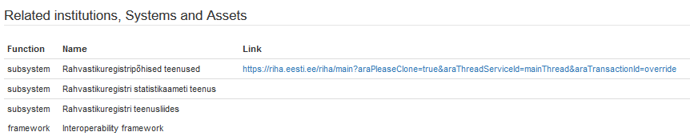

5.1.3. Field Group: Contact Persons
Repeating: unlimited, hidden: yes

Name. Name of contact persons. Example: John Smith

E-mail. Official e-mail of contact person. Example: John.Smith@eesti.ee

Phone. Official phone of contact person. Example: +372 513 9999

Function. Position and function of person in Institution. Example: architect , responsible for population register.

5.1.4. Field Group: Tools. Standards. Protocols

Repeating: unlimited, hidden: no

Function. Type of tool, facility, resource used in IS. List of types is unlimited and open. Example: operating system

Name. Name of tool. Example: Ubuntu

Example of field group:
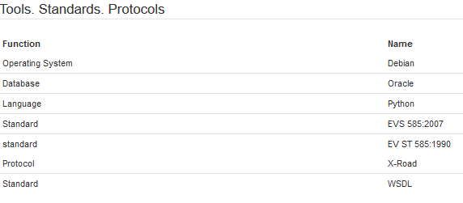

5.1.5. Field Group: Events and Decisions
Repeating: unlimited, hidden: yes.

Type. Type of event. Example: Approval.

Date. Date chosen from calendar. Example: 2016-03-16

Decision. Description of decision. Example. Architecture of register approved. Procurement process can be started

5.2. Section: Parameters

5.2.1. Field Group: SLA, security and other parameters
Repeating: unlimited, hidden: no

Parameter Name. Type of parameter used in IS for describing SLA, security level, availability, etc. List of types is unlimited and open. Example: availability

Value. Value of parameter. Example: 99.90%

Example of field group:
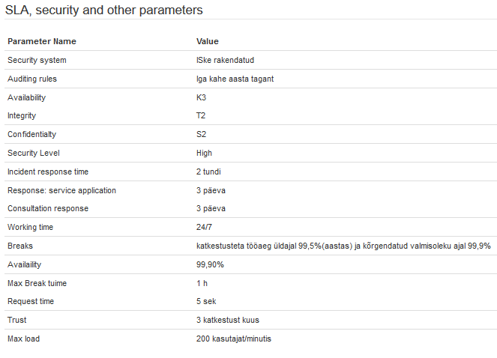

5.3. Section: Data description

5.3.1. Field Group: Documents
Repeating: unlimited, hidden: no

Description. Description of document describing data of IS in form of XMI, UML, XSD, etc. List of types is unlimited and open. Example: Data description: XMI.

URL. Link to the document. Example: https://www.riigiteataja.ee/akt/122112013002

File. File name uploaded to CatIS. Example: rr-data-description.xmi

5.3.2. Field group: Data objects and Elements

Repeating: unlimited, hidden: no

Level. Level of hierarchy. Example 2.

Element name. Element name in IS. Example: fn

Comment: Clarification. Example: First name

Attributes. Checkbox options: Personal Data, Sensitive Data, Base Data, Archive value.

Owner. Owner of data. Name of IS who is responsible for this piece of data. If possible CatIS internal link to the owner IS

Example of field group (fragment)
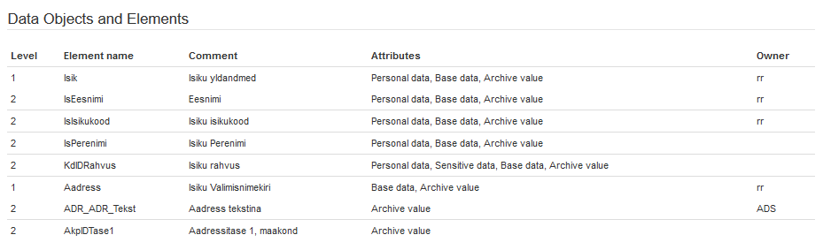

5.4. Section: Documents

5.4.1. Field group: Base Documents

Repeating: unlimited, hidden: no

Name. Name of document. Example: Regulation (EU) No 910/2014 of the European Parliament and of the Council of 23 July 2014 on electronic identification and trust services for electronic transactions in the internal market and repealing Directive 1999/93/EC

Issuer. Issuer of document. Example: European Parliament

URL. Link to the document in Internet. Example http://eur-lex.europa.eu/legal-content/EN/TXT/?uri=CELEX:32014R0910

File. Name of uploaded file

5.4.2. Field group: Technical Documents

Repeating: unlimited, hidden: no

Function. Type of function of technical document. Example: Reference architecture.

Name. Name of technical document. Example. CatIS Installation Guide.

URL. Link to the document if it is available in Internet.

File. Name of uploaded file in CatIS.

6. Data about services

6.1. Section: Service

6.1.1. Field group: General Data
Repeating: 1, hidden: no

Name. Name of service. Default element. You do not need define this element. It is generated by system. Example: Personal data

Identifier. Short name or code of service. Default element. You do not need define this element. It is generated by system. Example: rr404

Description. Service description. Example: Isikuandmed isikukoodide alusel. RR404 - Teenus tagastab edastatud isikukoodidele ja väljastavate andmeväljade loendile vastavate isikute andmed.

Classification. Classification of service. Checkbox options: X-Road, Open Webservice, Webpage. Example: X-Road

Personal Data: Attribute indicating whether service includes personal data and/or sensitive data. Checkbox options: No, Yes, Sensitive. Example: Yes, Sensitive

WSDL. Name and link to the WSDL file

Service URL. Link to the website if available.

Rules of Use. The principles of using the service. Example: Teenus on ava
tud kõigile Rahvastikuregisti Seaduses näidatud subjektile. Eaisik saab näha tema kohta registreeritud infot. Asutused saavad taotleda teenuse avamist CatIS-e administraatori kaudu

6.1.2. Field group: Service Level Agreements
Repeating: unlimited, hidden: no

Parameter Name. Type of parameter used in IS for describing SLA, security level, availability, etc. List of types is unlimited and open. Example: Integrity

Value. Value of parameter. Example: T2

Example of field group:
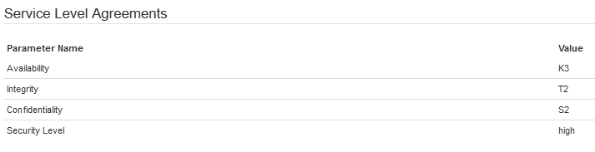

6.1.3. Field group: Namespaces

Repeating: unlimited, hidden: no

Namespace. Namespace used in service.
Example: soap : http://schemas.xmlsoap.org/wsdl/soap/
Example of field group:
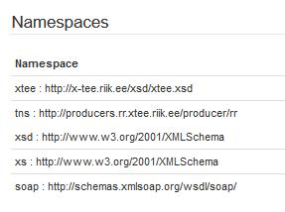

6.1.4. Field group: Service input
Repeating: unlimited, hidden: no

Level. Level of hierarchy. Example 2.

Fieldname. Element name in IS. Example: cSugu

Fieldtype. Type of data element. Example: xs:string

Name: Clarification. Example: First name

Example of field group (fragment)

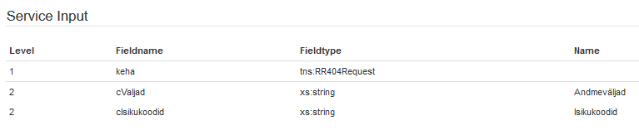

6.1.5. Field group: Service Output
Repeating: unlimited, hidden: no

Level. Level of hierarchy. Example 3.

Fieldname. Element name in IS. Example: cEKAadres

Fieldtype. Type of data element. Example: xs:string

Name: Clarification. Example: Elukoha aadress tekstina

Example of field group (fragment)
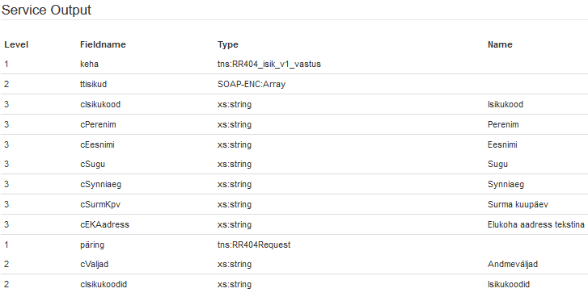

6.1.6. Field Group: Contact Persons
Repeating: unlimited, hidden: yes

Name. Name of contact persons. Example: Hanna Trump

E-mail. Official e-mail of contact person. Example: Hanna.Trump@eesti.ee

Phone. Official phone of contact person. Example: +372 513 9999

Function. Position and function of person in Institution. Example: chief of service department, responsible for service.

6.1.7. Field Group: Consumers

Repeating: unlimited, hidden: no

Name. Name of consumer organization

Link. Internal CatIS link to the institution.

7. Data about assets

7.1. Section: Asset

7.1.1. Field group: General Data
Repeating: 1, hidden: no

Name. Name of asset. Default element. You do not need define this element. It is generated by system.Example: Interoperability framework

Identifier. Short name or code of service. Default element. You do not need define this element. It is generated by system. Example: EIF

Owner. Responsible for asset. Example: European Commission

State of Asset. Checkbox options: Planned, Registered, Valid, Retired,

Regularity of Update. Rules of updating

Valid From. Date chosen from calendar

Info. Description of asset

7.1.2. Field Group: Contact Persons
Repeating: unlimited, hidden: yes

Name. Name of contact persons. Example: Liisi Lilleke

E-mail. Official e-mail of contact person. Example: Liisi.Lilleke@eesti.ee

Phone. Official phone of contact person. Example: +372 513 9999

Function. Position and function of person in Institution. Example: chief of service department, responsible for service.

7.1.3. Field group: Documents

Repeating: unlimited, hidden: no

Function. Type of function of document describing asset. Example: XML Shema

Name. Name of document describing asset. Example. XML Schema of code list of products.

URL. Link to the document if it is available in Internet.

File. Name of uploaded file in CatIS.

7.1.4. Field Group: Events and Decisions
Repeating: unlimited, hidden: yes.

Type. Type of event. Example: Approval.

Date. Date chosen from calendar. Example: 2016-03-16

Decision. Description of decision. Example. Architecture of register approved. Procurement process can be started

